**Experiment no. 05**

* 1. **Experiment Name**

Experimental study of ASK and FSK modulation and demodulation techniques

* 1. **Objectives**
* To understand the operation of ASK modulation and demodulation techniques
* To get acquainted with FSK modulation and demodulation techniques
* To observe input and output waveshapes of both techniques individually
  1. **Theory**

**Amplitude-shift keying (ASK)** is a type of amplitude modulation in which digital data is represented as fluctuations in the amplitude of a carrier wave. A symbol representing one or more bits is delivered in an ASK system by delivering a fixed-amplitude carrier wave at a given frequency for a specific time length.

For example, if each symbol represents a single bit, the carrier signal could be carried at full amplitude when the input value is 1, but at decreased amplitude or not at all when it is 0.

**Frequency-shift keying (FSK)** is a frequency modulation method that transmits digital information via discrete frequency shifts in a carrier signal. Binary FSK is the most basic type of FSK (BFSK). To transmit binary data, BFSK employs a pair of discrete frequencies (0s and 1s).

For example, Telemetry, weather balloon radiosondes, caller ID, garage door openers, and low frequency radio transmission in the VLF and ELF.

* 1. **Apparatus**
* Oscilloscope
* ASK modulation and demodulation kit
* FSK modulation and demodulation kit
* Jumper Wires
  1. **Block Diagram & Kit**

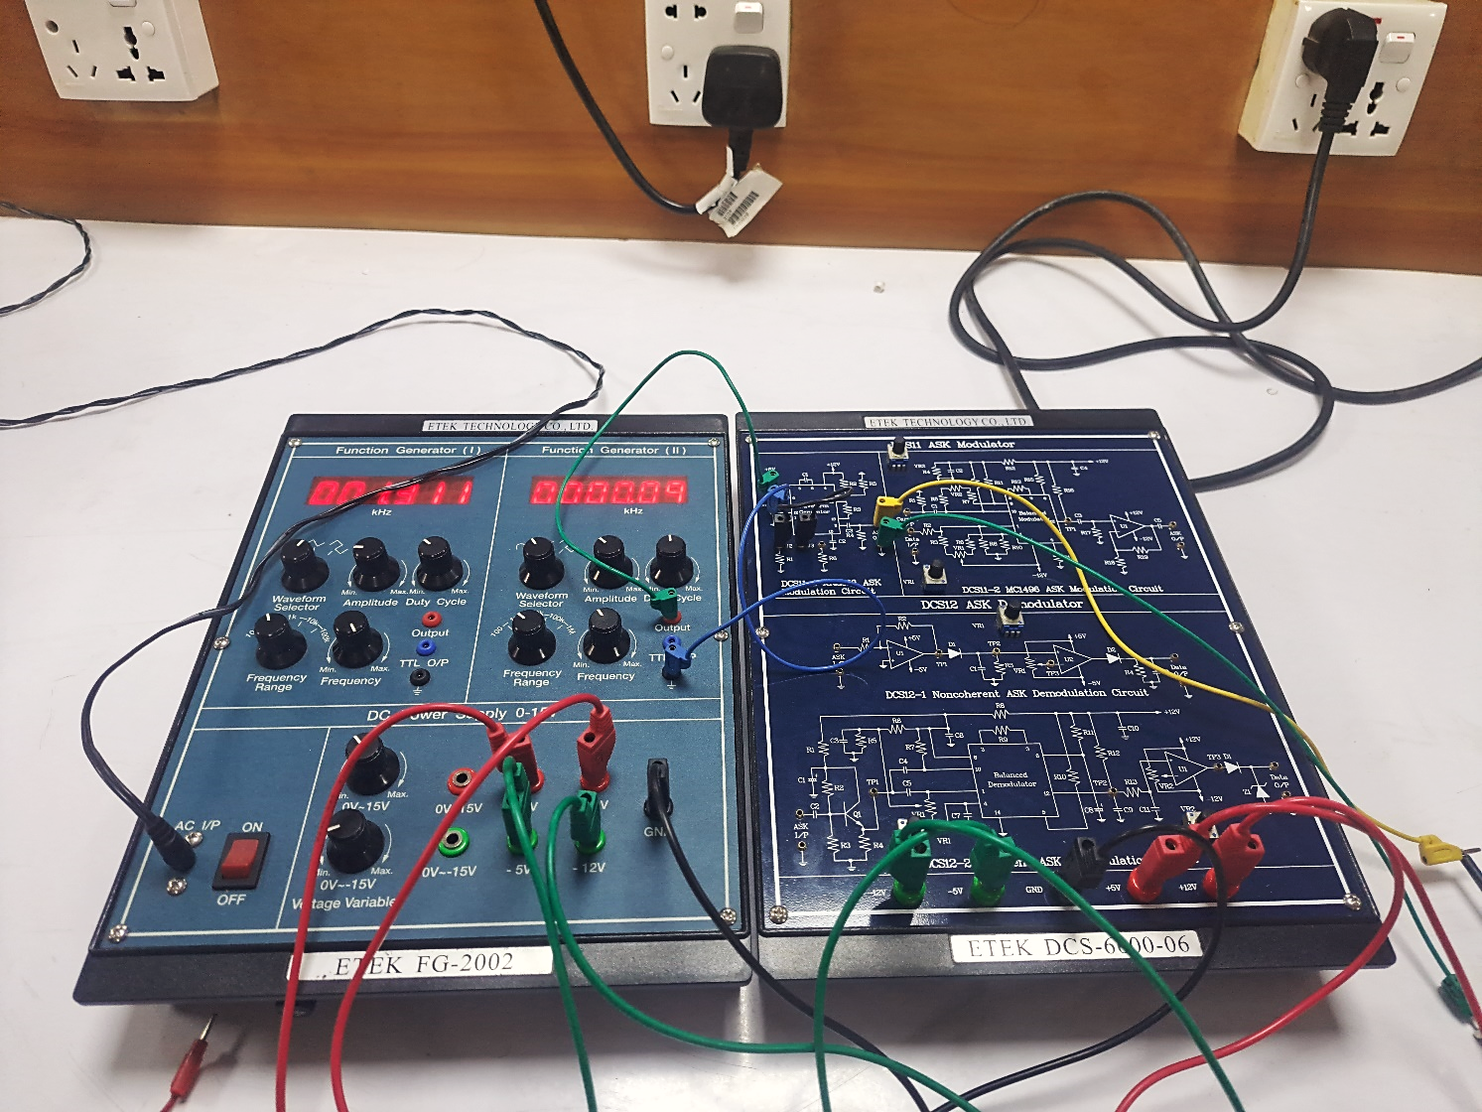

Fig.05.1: Experimental setup for ASK modulation and demodulation

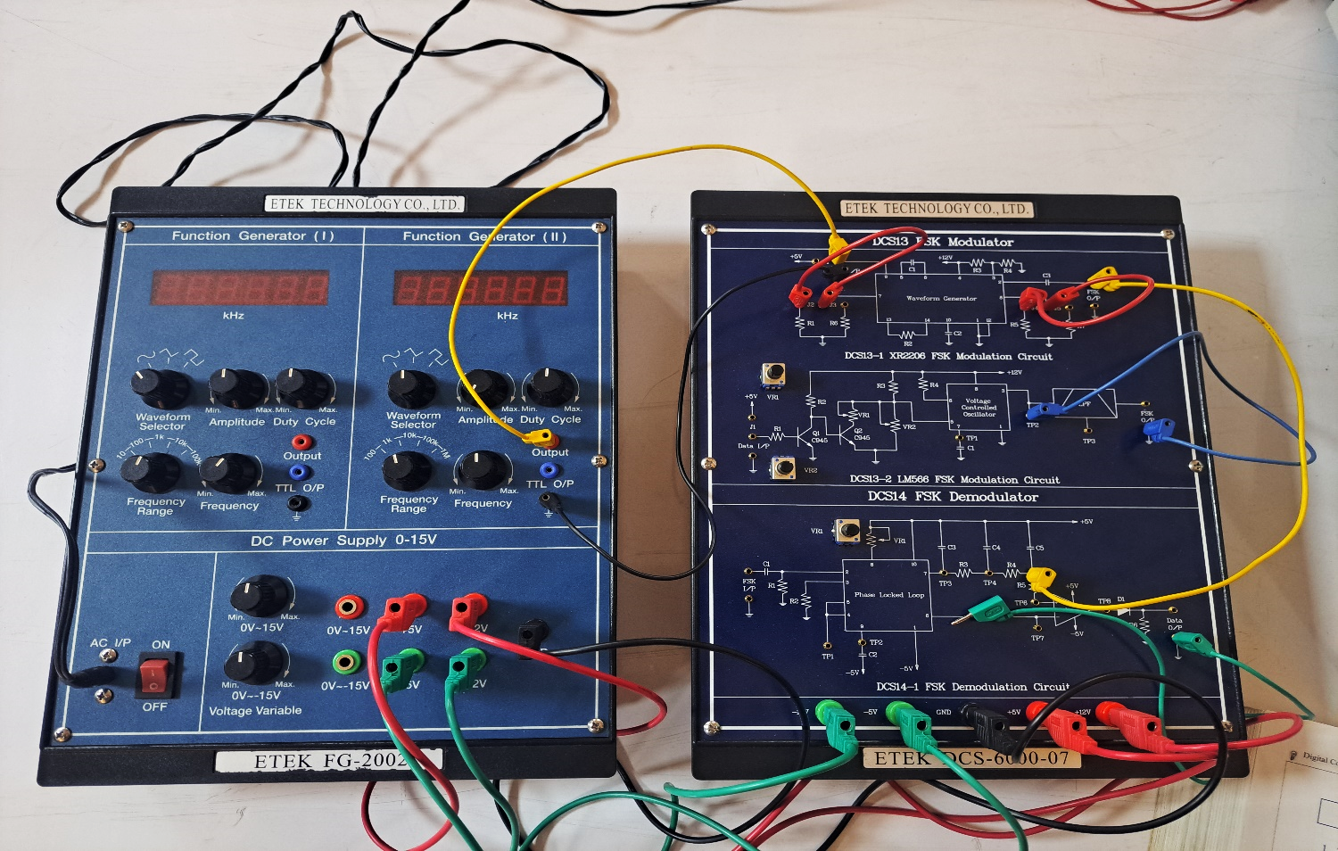

Fig.05.1: Experimental setup for FSK modulation and demodulation

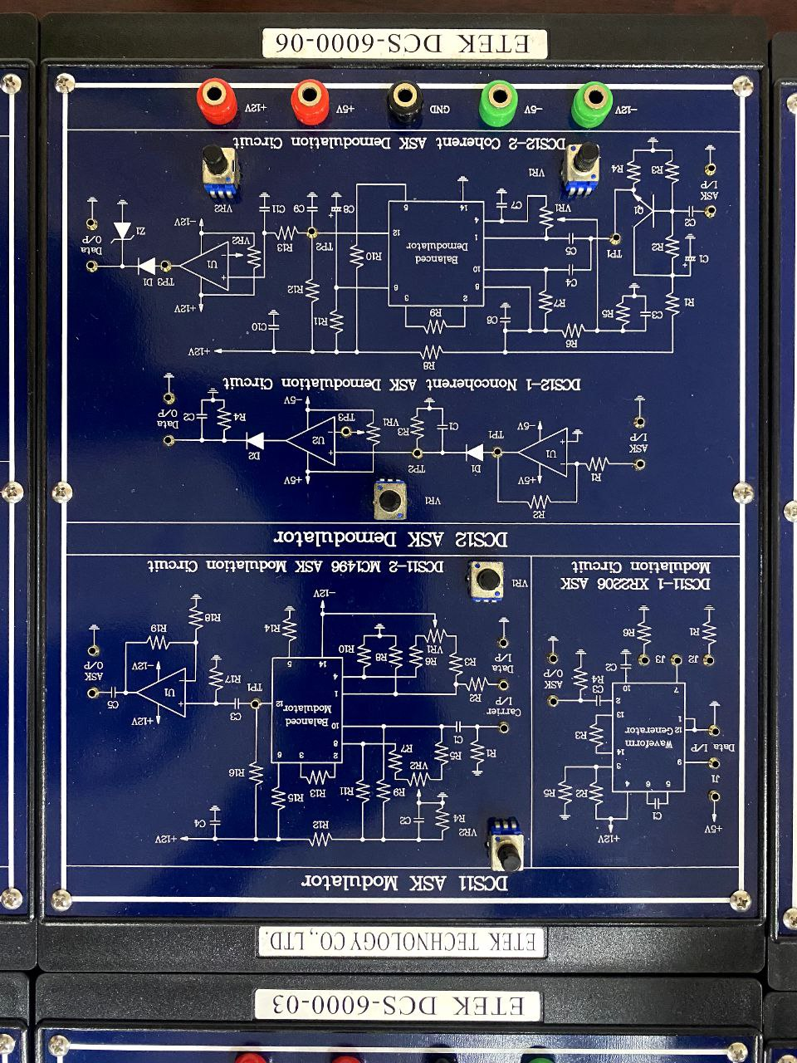 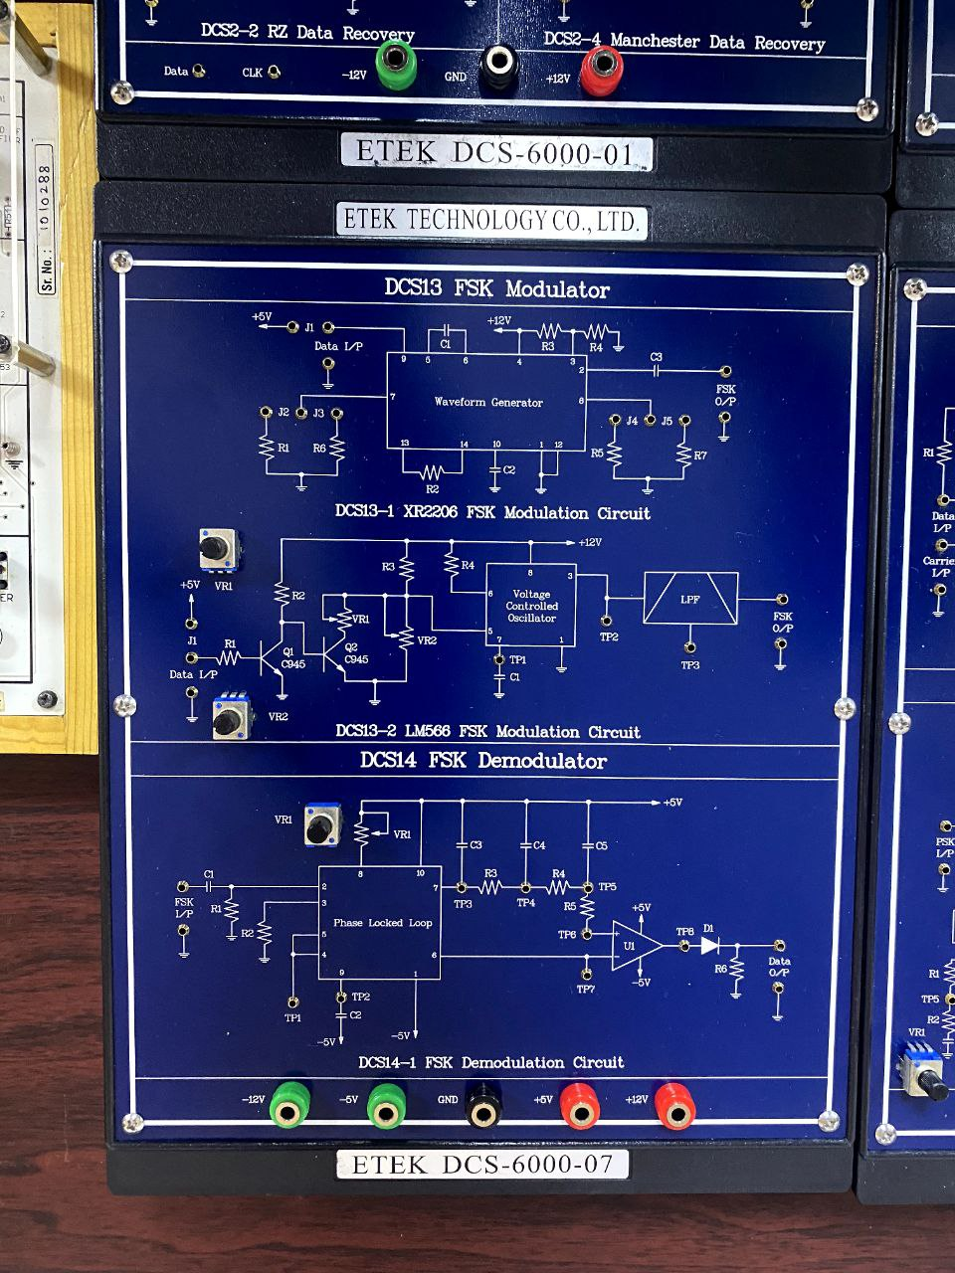

Fig.05.3: ASK modulation and demodulation kit Fig.05.4: FSK modulation and demodulation kit

* 1. **Waveforms**
* **ASK modulated and demodulated signal**

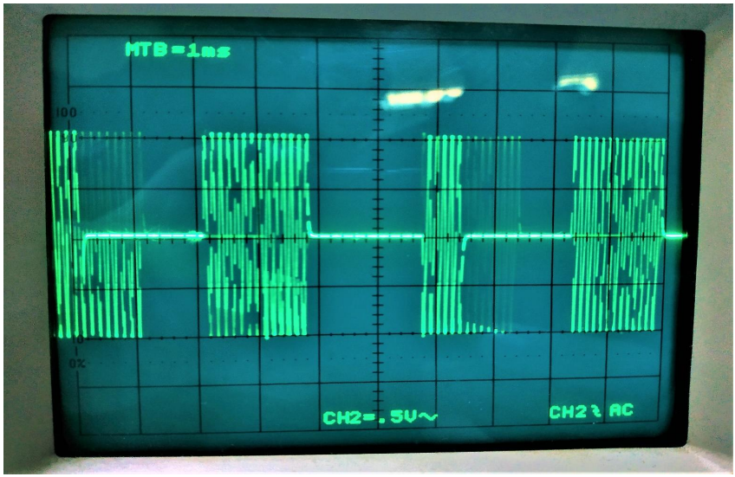 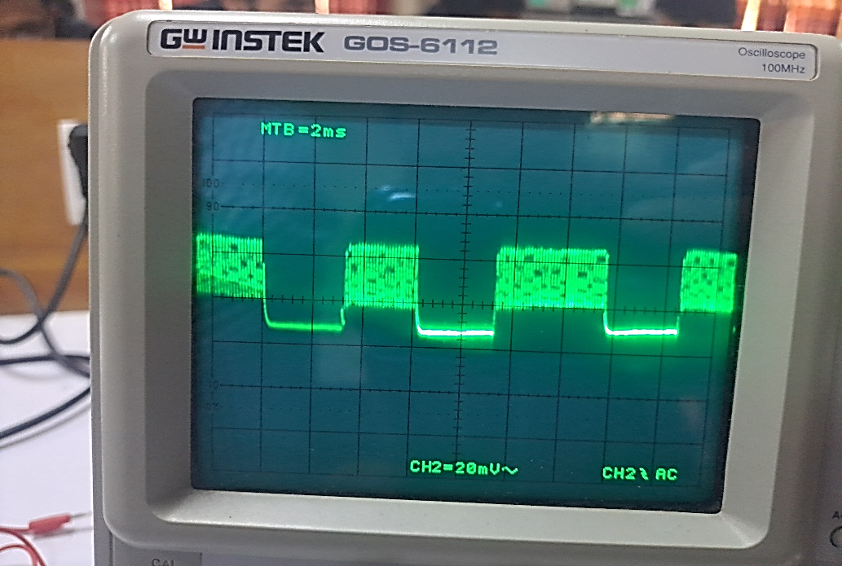

Fig.05.5: ASK modulated signal Fig.05.6: ASK demodulated signal

* **FSK modulated and demodulated signal**

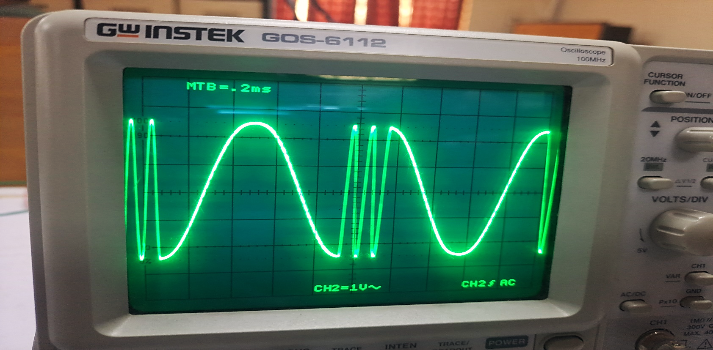

Fig.05.5: FSK demodulated signal

* 1. **Discussion & Conclusion**

In this experiment, the functions and purposes of ASK and FSK modulated and demodulated signal through laboratory kits were briefly reviewed. Their operation and working principle were also learnt and discussed.

The initial method was amplitude shift keying (ASK). The connections were made according to the instructions, the output was visible through the scope, and the signal generator generated the input pulse.

In the second scenario, frequency shift keying (FSK) was used. The modulated output was discovered after the pulse was delivered to the modulator kit. The modulated data was demodulated further, and the output was examined using a scope. In both cases, the expected result as manual was discovered. Thus, the experiment was carried out properly.

* 1. **Reference**
* Book: Electronic Communication System- George Kennedy
* <https://www.elprocus.com/frequency-shift-keying-fsk-working-applications/>
* <https://en.wikipedia.org/wiki/Amplitude-shift_keying>
* https://en.wikipedia.org/wiki/Frequency-shift_keying